BUSCOMONZEFI.COM – PERSONNEL POLICY AND PROCEDURE

DRESS CODE POLICY



STATEMENT OF PURPOSE
All employees have a direct impact on the image of our company. We have established an image of professionalism and expect its employees, on all levels, to reinforce this image, both to customers and co-workers at all times.

General guidelines and enforcement of policy:
We will not discriminate in the administration of this policy and has the right to change or modify this dress code policy at any time. Managers should also inform their staff that our Business Casual Policy is a benefit, not a right, and may also be changed at management’s discretion.

We have approved a Dress Code Policy that defines Professional Dress (for Customer Facing employees) and Business Casual Dress (for Non Customer Facing Employees). Employees are expected to adhere to the provisions of this policy.

If a manager or supervisor determines that an employee’s dress or personal grooming is unsuitable or offensive, the following guidelines will be administered:

- Supervisor should address the issues involved in private with a member of the Human Resources Department present – not in front of other employees.
- Human Resources and the Supervisor should explain what is inappropriate and coach employee(s) on what would be acceptable.
- If an employee wears something that is in violation of the Dress Code Policy, unless appearance is totally unacceptable, the employee may remain at work for that day but should be counseled not to violate the policy again,
- If the appearance is totally unacceptable or the employee comes to work dressed inappropriately after being counseled, the employee should be sent home to change.
- Employees who do not adhere to these guidelines will be subject to “progressive discipline” which may end in probation and possible termination including being sent home without pay.

PROFESSIONAL ATTIRE (Customer Facing Employees)

Definition of “Professional Attire”:
All employees are expected to present a professional, businesslike image to customers at all times. If an employee is in a “customer facing” position, they are required to be dressed professionally. Acceptable professional business appearance, like the proper maintenance of work areas, is an on-going requirement. (See examples on pages 3-4)

Appropriate Professional Attire for Men:
Men are asked to use discretion, good judgment and modesty in selecting their professional attire.
- Suits worn with collared shirts and coordinated ties, with dress shoes.
- Dress slacks and dress sport coat or blazer with collared shirt and coordinated tie, with appropriate dress shoes.

Appropriate Professional Attire for Women:
Women are asked to use discretion, good judgment and modesty in selecting their professional attire.
- Coordinated business suits and dress shoes
- Coordinated dress pant suits with dress shoes
- Skirts, blouse or sweater with jacket or blazer with dress shoes
- Skirts and blouses with dress shoes

Below are examples of Acceptable Professional Dress:



Appropriate Professional Dress Attire for Men:

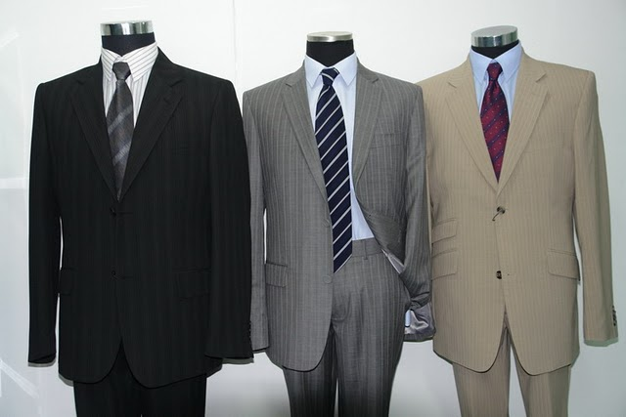

Appropriate Professional Dress Attire for Women:

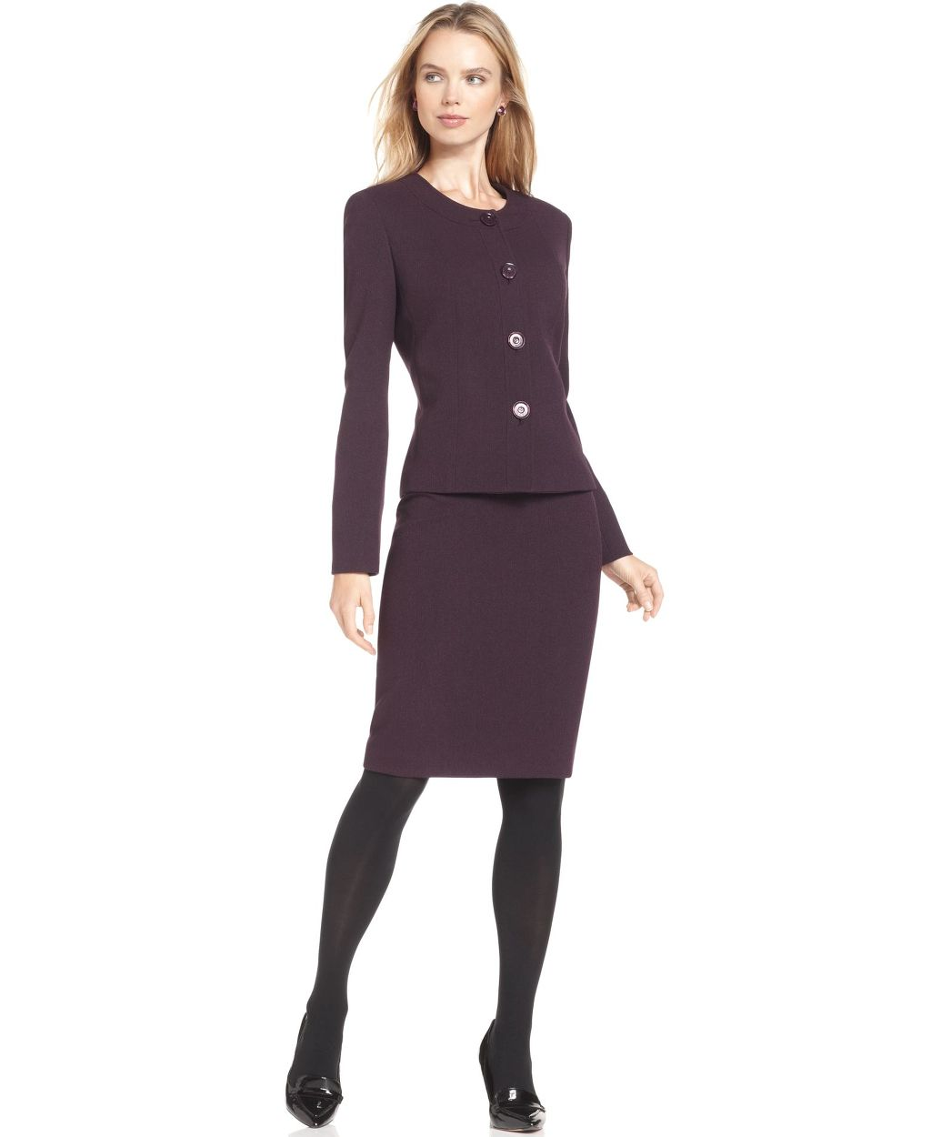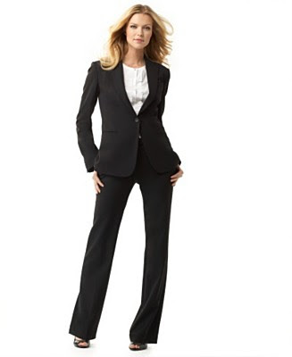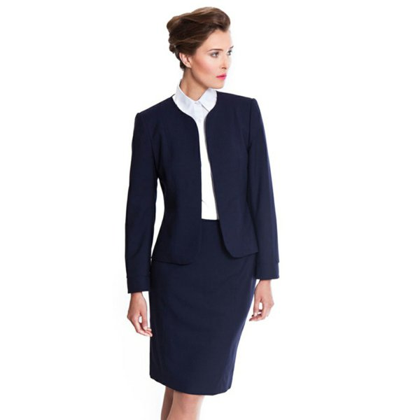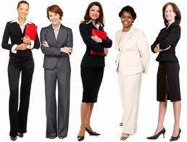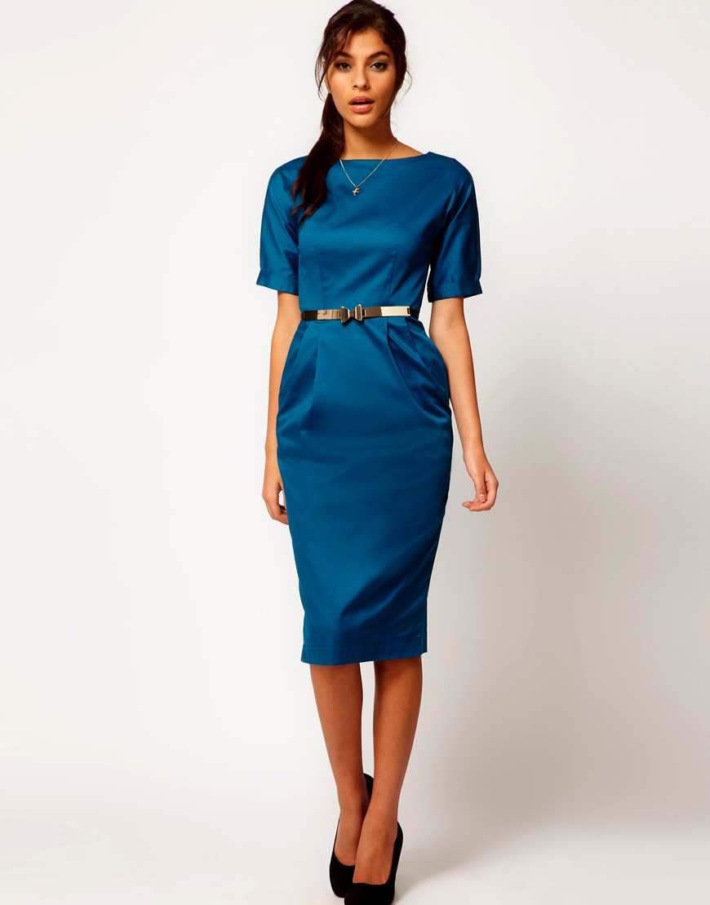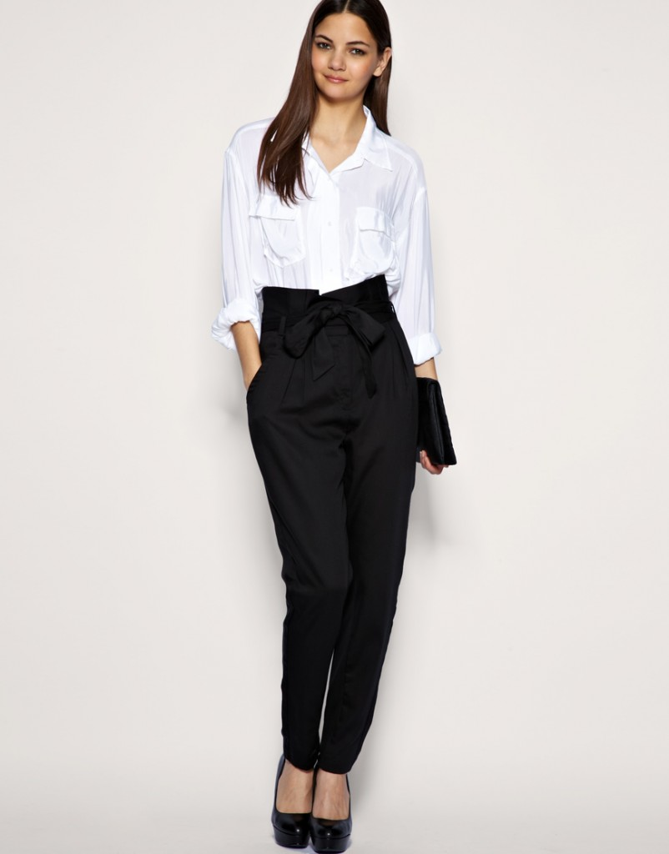

BUSINESS CASUAL DRESS (Non Customer Facing Employees)

Definition of “Business Casual”: Business Casual clothing is a way of dressing in the workplace that encourages comfort, professionalism and productivity. Business Casual is not the same as “Weekend Casual.” All employees are expected to use good judgment and dress appropriately when involved in meetings with customers, individuals or groups from the public or prospective customers/clients. (See examples on pages 7-8)

Administration:
All employees working in Back Office departments will be permitted to dress in “Business Casual” clothing every day unless they have a customer/client meeting they must attend where they must dress in professional attire. At said meetings, appropriate Professional Business attire is required.

Appropriate Business Casual attire for Men:
- Blazer or sport coat
- Long sleeved dress shirt
- Neckwear is optional
- Trousers- Dress pants, chinos/khakis, corduroy pants
- Sweater vests or cardigans

Personal Grooming:
Beards, mustaches, and side-burns should be neat and trimmed. Body markings or body piercings of any type that may be considered offensive or inappropriate must be covered or removed.

Appropriate Business Casual attire for Women:
- Pant suits, pants, or a skirt, with a blouse, jacket or V-neck, turtleneck, or crewneck sweater. Pants may be khakis, corduroys, slacks of cotton, linen or wool.
- Dresses, short or long skirts with coordinated tops or sweater sets
- Heeled or low-heeled shoes, appropriate sandals, loafers and/or other leather-type soled shoes.
- Capris/Crops must be at least mid-calf and of a dressy nature. (No strings, cargo pants or skin tight, form fitting styles.)
- Sleeveless styles that extend to the edge of the shoulders are permitted without additional cover
- Hosiery will be optional during the summer months. During the winter months hosiery must be worn with dresses and skirts. No pattern tights should be worn.

Personal Grooming:
Women are asked to dress appropriately and in good taste for the workplace. Overly tight clothing is not appropriate. Body markings or body piercings of any type that may be considered offensive or inappropriate must be covered or removed. Pierced earrings should be suitable for the workplace.

The following clothing/footwear is inappropriate and is not permitted for Men and Women:
- Short, tight skirts or dresses that ride above the mid-thigh (standing or sitting)
- Denim jeans, dresses, skirts or jackets of any color
- Mini-skirts, culottes or skorts. Maxi skirts or dresses that are made of jersey (T-shirt material) or are of a “beachy” nature
- Halter tops or spaghetti straps
- All sun dresses and dresses with spaghetti straps, bare shoulders or backs much be worn with a jacket or sweater
- Leggings, Yoga or Velour pants
- Midriff tops, low cut or see-through blouses
- Shorts
- Flip-flop or T-strap sandals of any type
- Crocs or stiletto heels
- T-shirts
- Sweatshirts, sweatpants, or jogging outfits
- Sneakers or tennis shoes of any type; work or hiking boots.
- Wrinkled clothing- shirts or pants

Below are examples of Acceptable Business Casual:

Appropriate Business Casual Attire for Men:

Pants

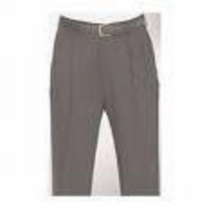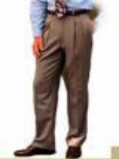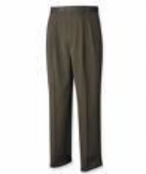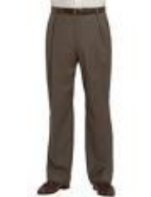

Shirts/Tops
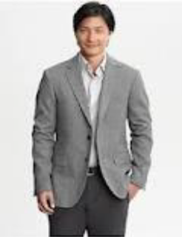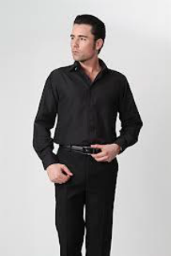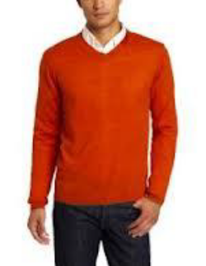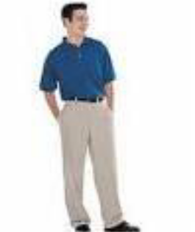

Shoes

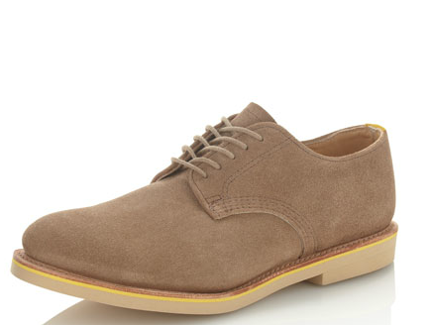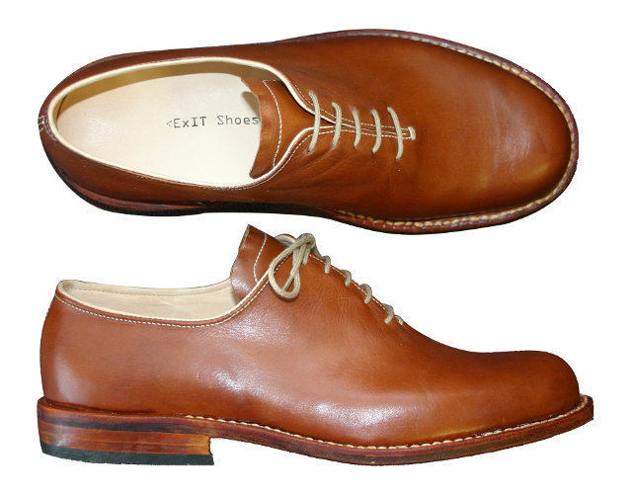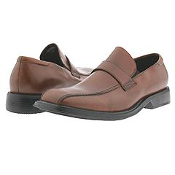

Appropriate Business Casual Attire for Women:

Slacks/Pants
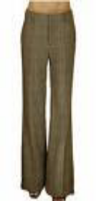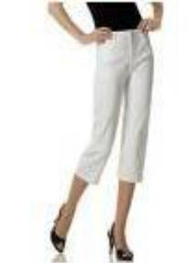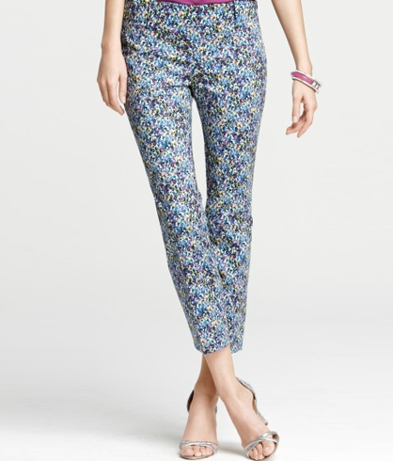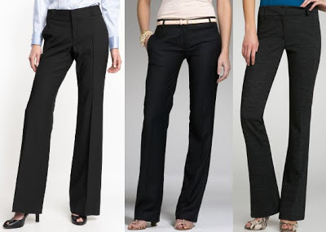

Dresses/skirts
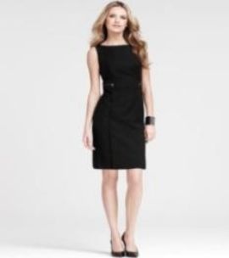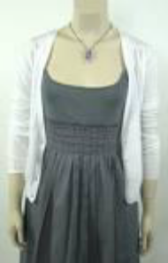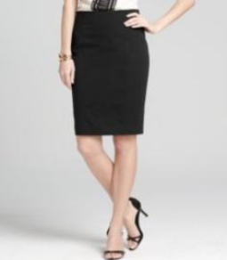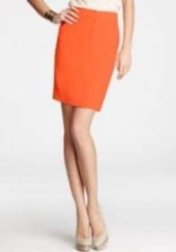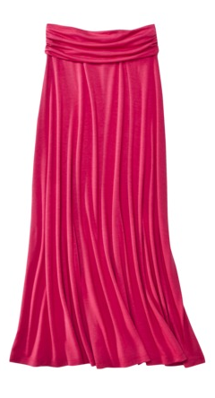

Blouses/shirts/tops
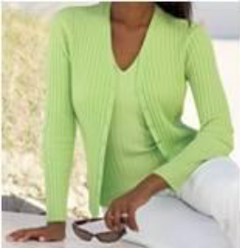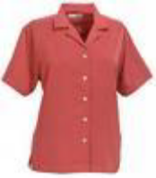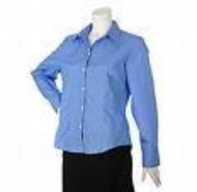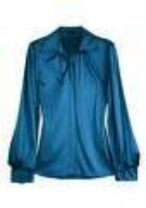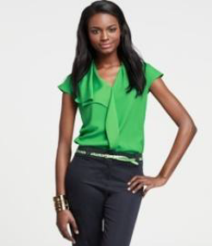

Shoes


